**Know Thy Complexities!**

Hi there!  This covers the space and time Big-O complexities of common algorithms used in Computer Science.

**Big-O Complexity Chart**

|  |  |  |  |  |
| --- | --- | --- | --- | --- |
| Horrible | Bad | Fair | Good | Excellent |

O(log n), O(1)O(n)O(n log n)O(n^2)O(2^n)O(n!)OperationsElements

**Common Data Structure Operations**

|  |  |  |  |  |  |  |  |  |  |
| --- | --- | --- | --- | --- | --- | --- | --- | --- | --- |
| Data Structure | Time Complexity | | | | | | | | Space Complexity |
|  | Average | | | | Worst | | | | Worst |
|  | Access | Search | Insertion | Deletion | Access | Search | Insertion | Deletion |  |
| [Array](http://en.wikipedia.org/wiki/Array_data_structure) | Θ(1) | Θ(n) | Θ(n) | Θ(n) | O(1) | O(n) | O(n) | O(n) | O(n) |
| [Stack](http://en.wikipedia.org/wiki/Stack_(abstract_data_type)) | Θ(n) | Θ(n) | Θ(1) | Θ(1) | O(n) | O(n) | O(1) | O(1) | O(n) |
| [Queue](http://en.wikipedia.org/wiki/Queue_(abstract_data_type)) | Θ(n) | Θ(n) | Θ(1) | Θ(1) | O(n) | O(n) | O(1) | O(1) | O(n) |
| [Singly-Linked List](http://en.wikipedia.org/wiki/Singly_linked_list#Singly_linked_lists) | Θ(n) | Θ(n) | Θ(1) | Θ(1) | O(n) | O(n) | O(1) | O(1) | O(n) |
| [Doubly-Linked List](http://en.wikipedia.org/wiki/Doubly_linked_list) | Θ(n) | Θ(n) | Θ(1) | Θ(1) | O(n) | O(n) | O(1) | O(1) | O(n) |
| [Skip List](http://en.wikipedia.org/wiki/Skip_list) | Θ(log(n)) | Θ(log(n)) | Θ(log(n)) | Θ(log(n)) | O(n) | O(n) | O(n) | O(n) | O(n log(n)) |
| [Hash Table](http://en.wikipedia.org/wiki/Hash_table) | N/A | Θ(1) | Θ(1) | Θ(1) | N/A | O(n) | O(n) | O(n) | O(n) |
| [Binary Search Tree](http://en.wikipedia.org/wiki/Binary_search_tree) | Θ(log(n)) | Θ(log(n)) | Θ(log(n)) | Θ(log(n)) | O(n) | O(n) | O(n) | O(n) | O(n) |
| [Cartesian Tree](https://en.wikipedia.org/wiki/Cartesian_tree) | N/A | Θ(log(n)) | Θ(log(n)) | Θ(log(n)) | N/A | O(n) | O(n) | O(n) | O(n) |
| [B-Tree](http://en.wikipedia.org/wiki/B_tree) | Θ(log(n)) | Θ(log(n)) | Θ(log(n)) | Θ(log(n)) | O(log(n)) | O(log(n)) | O(log(n)) | O(log(n)) | O(n) |
| [Red-Black Tree](http://en.wikipedia.org/wiki/Red-black_tree) | Θ(log(n)) | Θ(log(n)) | Θ(log(n)) | Θ(log(n)) | O(log(n)) | O(log(n)) | O(log(n)) | O(log(n)) | O(n) |
| [Splay Tree](https://en.wikipedia.org/wiki/Splay_tree) | N/A | Θ(log(n)) | Θ(log(n)) | Θ(log(n)) | N/A | O(log(n)) | O(log(n)) | O(log(n)) | O(n) |
| [AVL Tree](http://en.wikipedia.org/wiki/AVL_tree) | Θ(log(n)) | Θ(log(n)) | Θ(log(n)) | Θ(log(n)) | O(log(n)) | O(log(n)) | O(log(n)) | O(log(n)) | O(n) |
| [KD Tree](http://en.wikipedia.org/wiki/K-d_tree) | Θ(log(n)) | Θ(log(n)) | Θ(log(n)) | Θ(log(n)) | O(n) | O(n) | O(n) | O(n) | O(n) |

**Array Sorting Algorithms**

|  |  |  |  |  |
| --- | --- | --- | --- | --- |
| Algorithm | Time Complexity | | | Space Complexity |
|  | Best | Average | Worst | Worst |
| [Quicksort](http://en.wikipedia.org/wiki/Quicksort) | Ω(n log(n)) | Θ(n log(n)) | O(n^2) | O(log(n)) |
| [Mergesort](http://en.wikipedia.org/wiki/Merge_sort) | Ω(n log(n)) | Θ(n log(n)) | O(n log(n)) | O(n) |
| [Timsort](http://en.wikipedia.org/wiki/Timsort) | Ω(n) | Θ(n log(n)) | O(n log(n)) | O(n) |
| [Heapsort](http://en.wikipedia.org/wiki/Heapsort) | Ω(n log(n)) | Θ(n log(n)) | O(n log(n)) | O(1) |
| [Bubble Sort](http://en.wikipedia.org/wiki/Bubble_sort) | Ω(n) | Θ(n^2) | O(n^2) | O(1) |
| [Insertion Sort](http://en.wikipedia.org/wiki/Insertion_sort) | Ω(n) | Θ(n^2) | O(n^2) | O(1) |
| [Selection Sort](http://en.wikipedia.org/wiki/Selection_sort) | Ω(n^2) | Θ(n^2) | O(n^2) | O(1) |
| [Tree Sort](https://en.wikipedia.org/wiki/Tree_sort) | Ω(n log(n)) | Θ(n log(n)) | O(n^2) | O(n) |
| [Shell Sort](http://en.wikipedia.org/wiki/Shellsort) | Ω(n log(n)) | Θ(n(log(n))^2) | O(n(log(n))^2) | O(1) |
| [Bucket Sort](http://en.wikipedia.org/wiki/Bucket_sort) | Ω(n+k) | Θ(n+k) | O(n^2) | O(n) |
| [Radix Sort](http://en.wikipedia.org/wiki/Radix_sort) | Ω(nk) | Θ(nk) | O(nk) | O(n+k) |
| [Counting Sort](https://en.wikipedia.org/wiki/Counting_sort) | Ω(n+k) | Θ(n+k) | O(n+k) | O(k) |
| [Cubesort](https://en.wikipedia.org/wiki/Cubesort) | Ω(n) | Θ(n log(n)) | O(n log(n)) | O(n) |

**Get the Official Big-O Cheat Sheet Poster**

[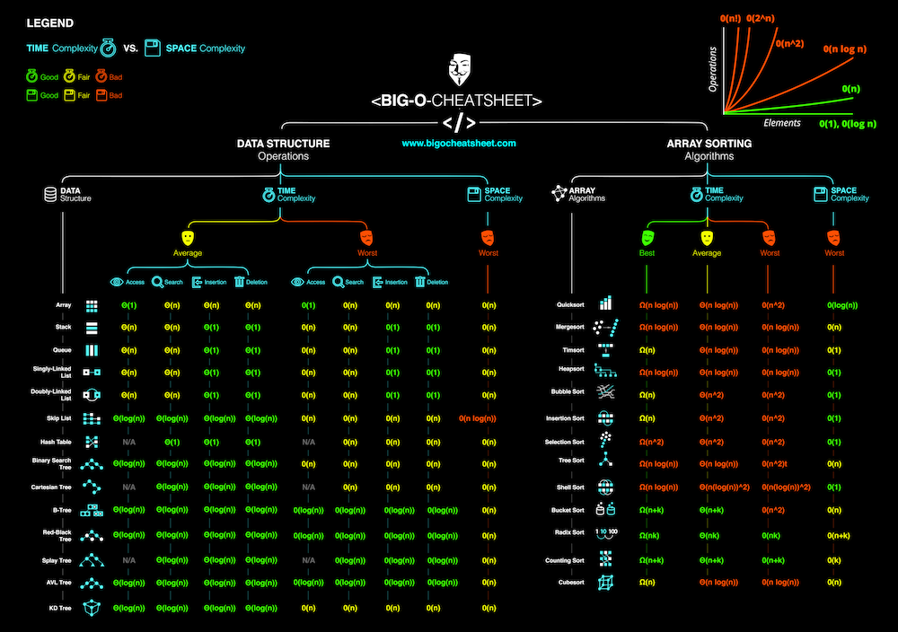](http://www.redbubble.com/people/immortalloom/works/22929408-official-big-o-cheat-sheet-poster?p=poster&finish=semi_gloss&size=large)